Wilson Sporting Goods

*User Guide*

|  |  |  |
| --- | --- | --- |
| **Supervisor.** | **Miss Nashmia Khan** | |
| **Batch.** | **2305F1** | |
| **Group.** |  | |
| **Serial No.** | **Enrollment Number** | **Student Name** |
| 1. | 1465057 | MUHAMMAD  AMIN BULAQI |
| 2. | 1465456 | MUHAMMAD  FAHAD SHEIKH |
| 3. | 1472864 | MUHAMMAD  NEHAL ALEEM |
| 4. | 1463403 | SAMEER MALIK |



1. **Home** (*index (1).html*)

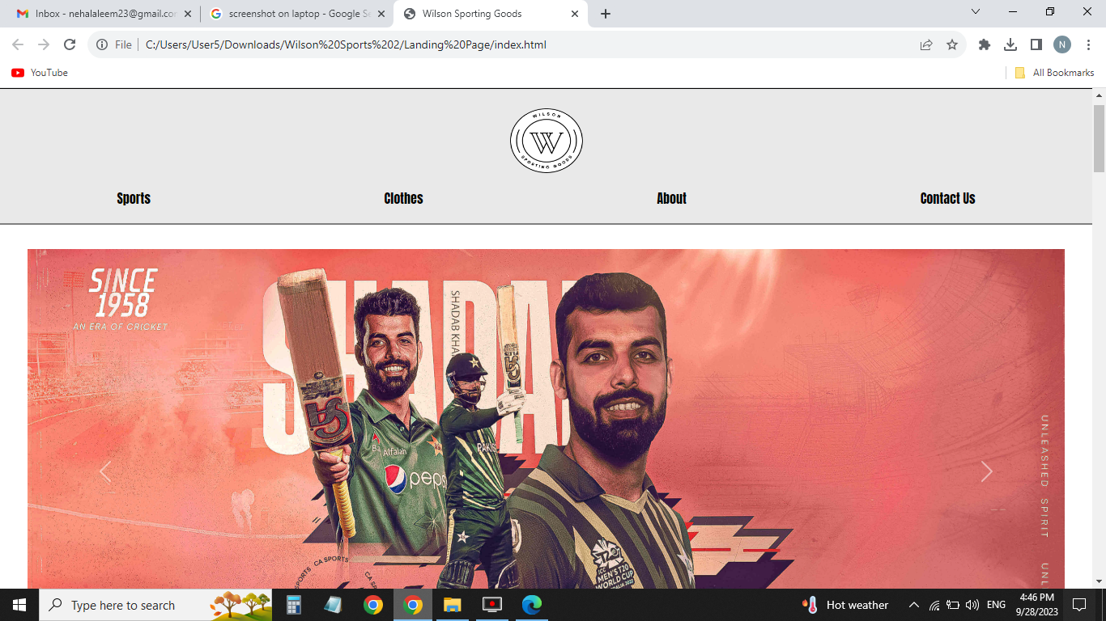

***Figure 1: Home page to Wilson Sporting Goods***

* By clicking (**Get started**) button user while redirect to the main webpage.

1. **Navbar (index (1).html)**

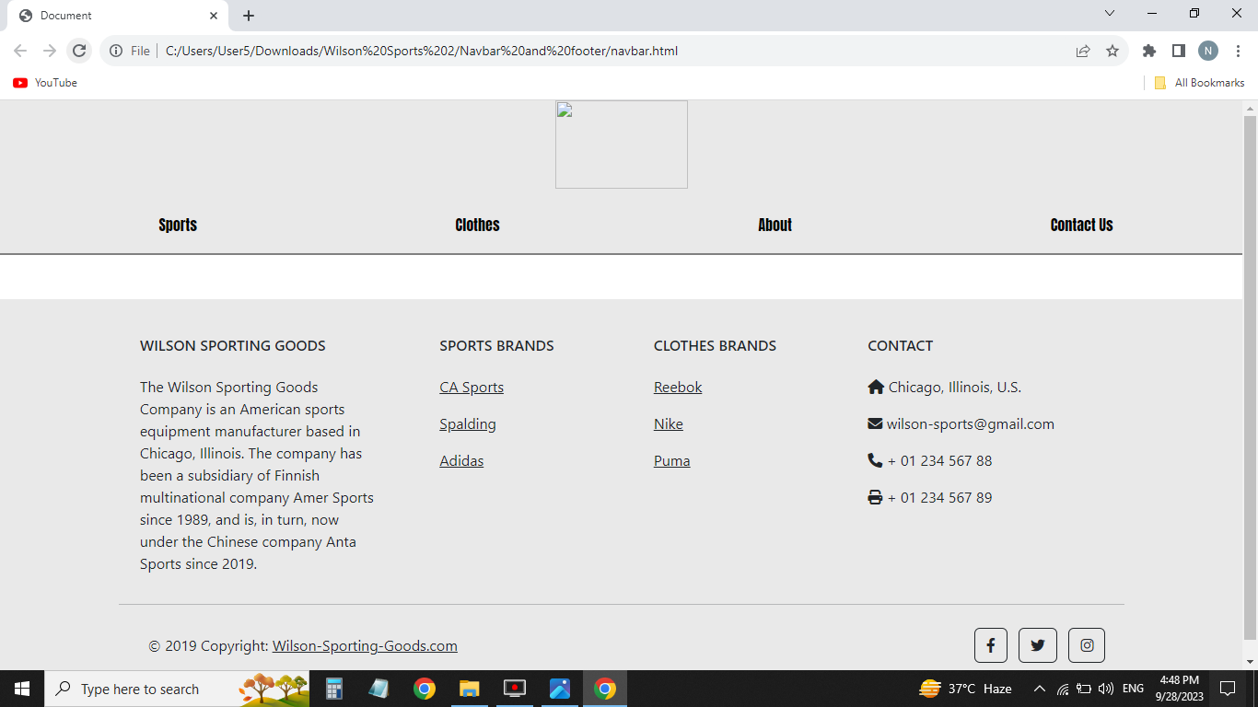

***Figure 2: Navbar***

We have given seven essentials. By clicking any of the essential’s and redirect to the linked page. (0. Index (1).html)

1. **About us (index (1).html)**

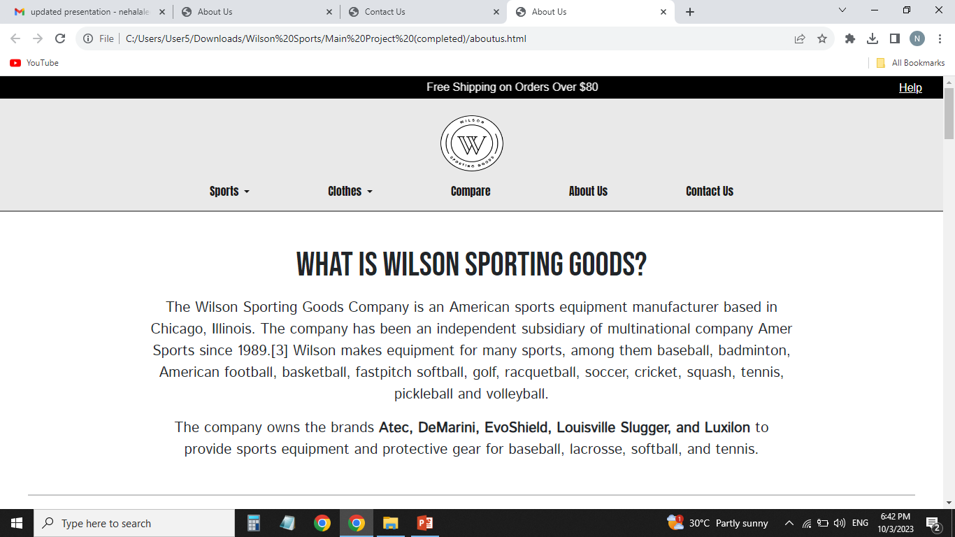

***Figure 3: About us***

**





***9.Our Team (index (1).html):***

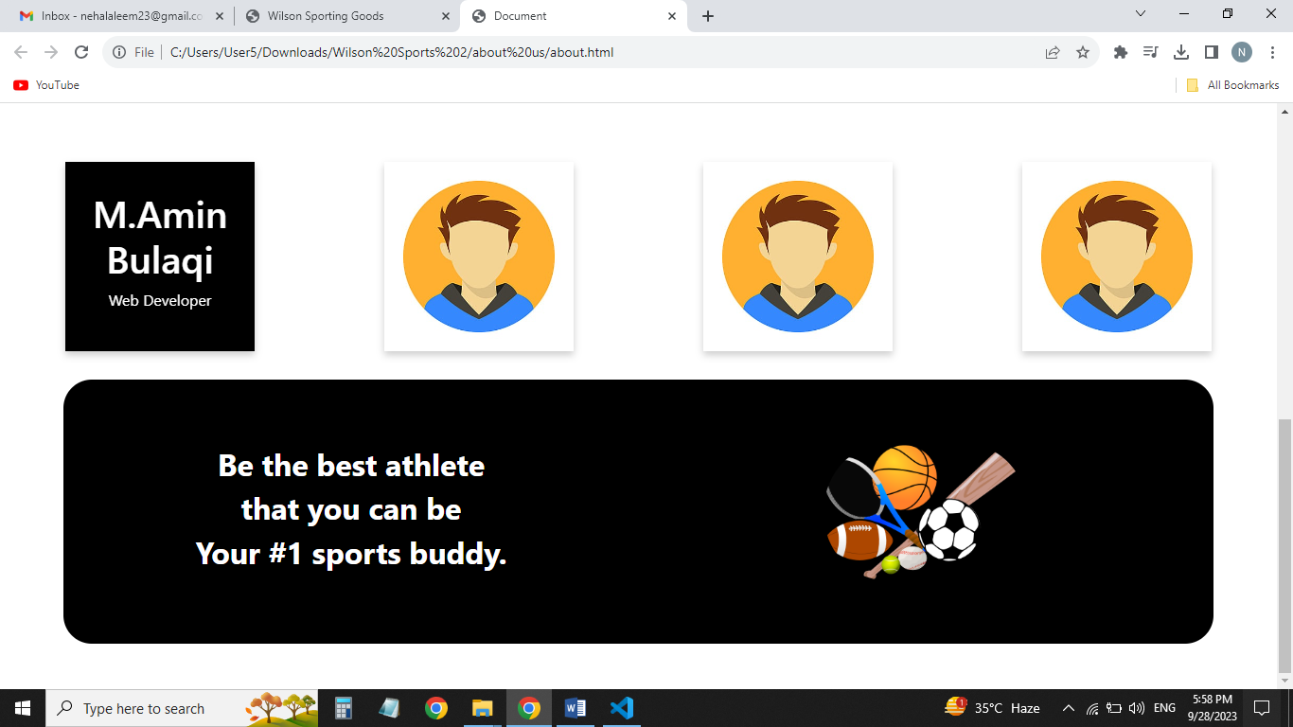



*Web Designer*

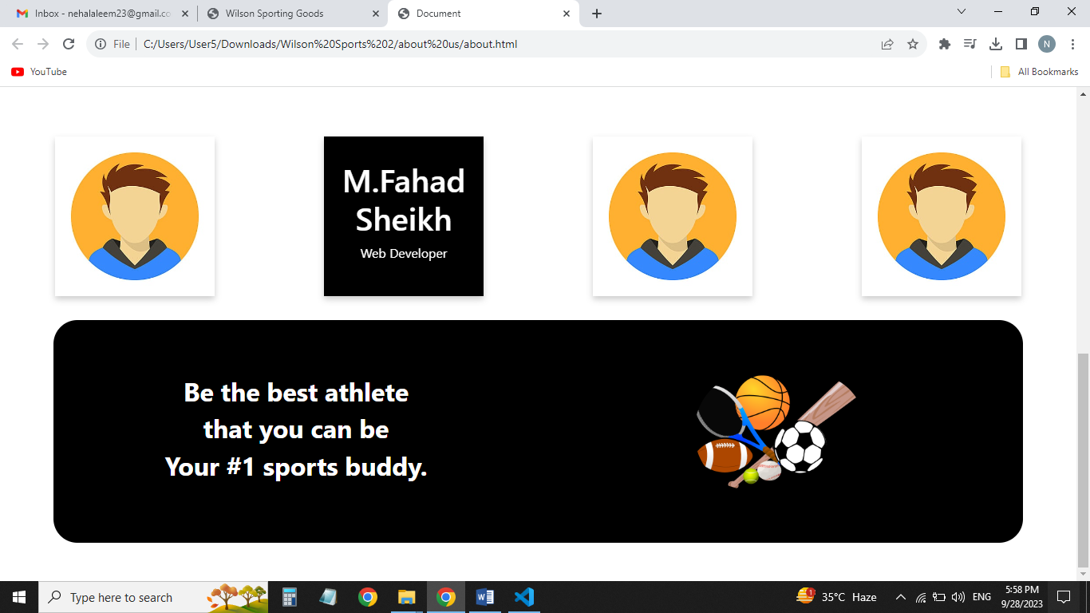



*Web Developer*

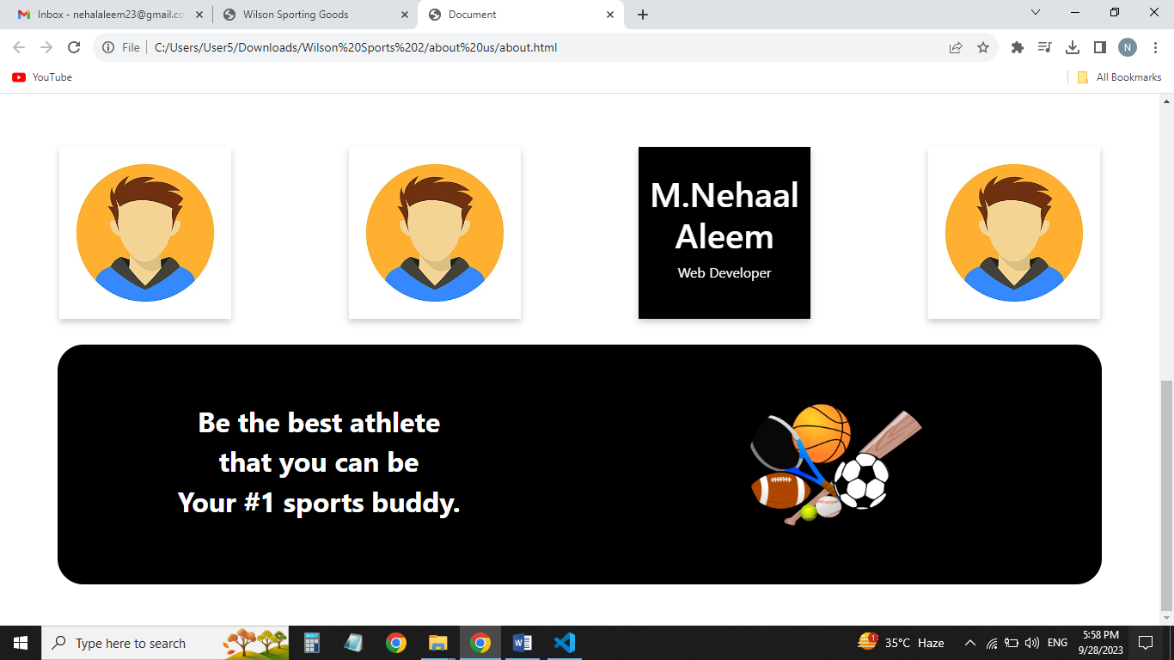



*Content Writer*

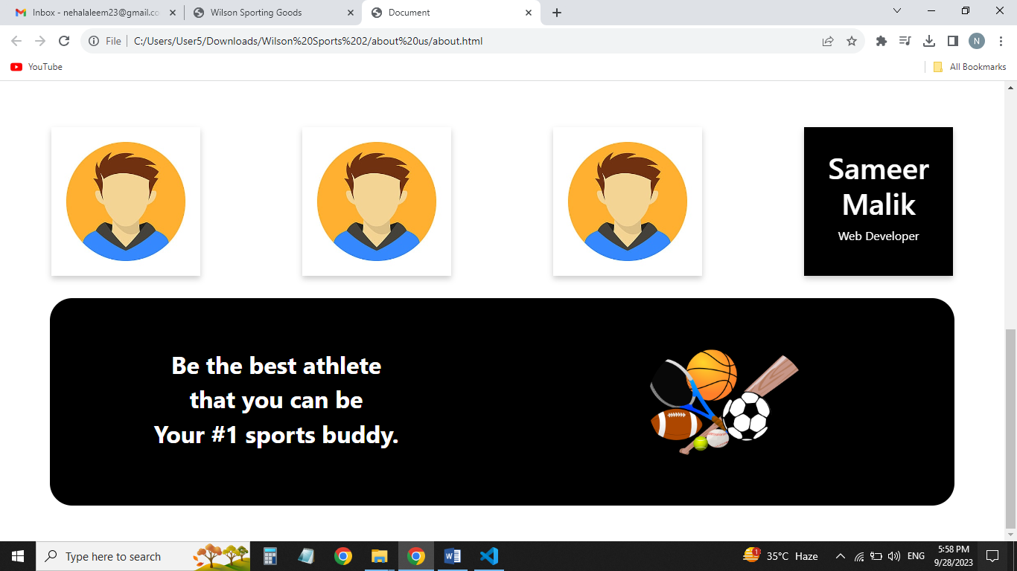



*Web Developer*

***13.Contact (index (1).html):***

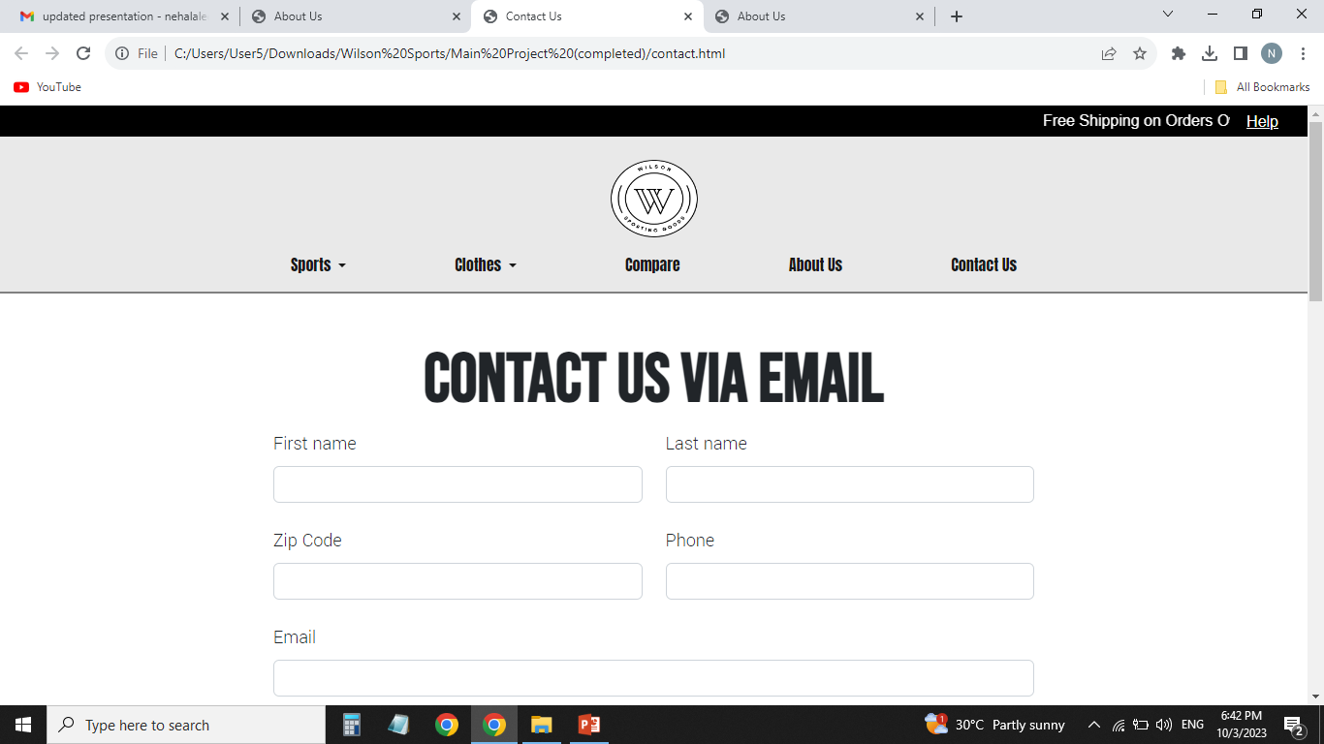

***Figure 13: Contact***

*In our contact section we have given location map for the ease of the people*

*Email id and phone number for contacting in case of any problem.*

*Feedback Form:*

*To know the response of the people our team has given feedback page for the ideas and feedback of the people.*